Set up vs code C++ on mac os and create hello world app.

1. Download and install vs code

[Download Visual Studio Code - Mac, Linux, Windows](https://code.visualstudio.com/Download)

1. Open vs code and install the extension of C++

1. Install C++ compiler, Clang. First use below command to check if complier has been installed already.

If Clang isn't installed, enter the following command to install the command line developer tools, which include Clang:

xcode-select –install

1. Create hello world app
   1. From the macOS Terminal, create an empty folder called projects where you can store all your VS Code projects, then create a subfolder called helloworld, navigate into it, and open VS Code in that folder by entering the following commands in the terminal window

mkdir projects

cd projects

mkdir helloworld

cd helloworld

code .

 As you go through the tutorial, three files are created in the .vscode folder in your workspace:

* tasks.json (compiler build settings)
* launch.json (debugger settings)
* c_cpp_properties.json (compiler path and IntelliSense settings)
  1. add new with name of helloword.cpp

And then paste below code into this file.

#include <iostream>

#include <vector>

#include <string>

using namespace std;

int main()

{

vector<string> msg {"Hello", "C++", "World", "from", "VS Code", "and the C++ extension!"};

for (const string& word : msg)

{

cout << word << " ";

}

cout << endl;

}

* 1. run helloworld.cpp

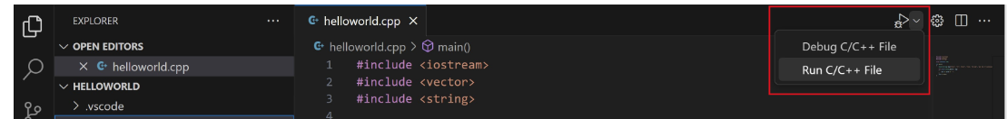

Choose **C/C++: clang++ build and debug active file** from the list of detected compilers on your system. You are only asked to choose a compiler the first time you run helloworld.cpp. This compiler is the "default" compiler set in tasks.json file.

{

"tasks": [

{

"type": "cppbuild",

"label": "C/C++: clang++ build active file",

"command": "/usr/bin/clang++",

"args": [

"-fcolor-diagnostics",

"-fansi-escape-codes",

"-g",

"${file}",

"-o",

"${fileDirname}/${fileBasenameNoExtension}"

],

"options": {

"cwd": "${fileDirname}"

},

"problemMatcher": ["$gcc"],

"group": {

"kind": "build",

"isDefault": true

},

"detail": "Task generated by Debugger."

}

],

"version": "2.0.0"

}

Details refer to below link.

[Using Clang in Visual Studio Code](https://code.visualstudio.com/docs/cpp/config-clang-mac#_prerequisites)